## **Introduction**

1. spring.io dependencies
2. <https://start.spring.io/>
   * Spring web
   * Spring security
   * Spring boot dev tools
   * postgreSQL driver
   * JPA

## **Test spring boot project**

1. Create dummy controller
   * Use annotations RestController for now
   * Use GetMapping
   * And return word for now “Welcome to Spring Boot”

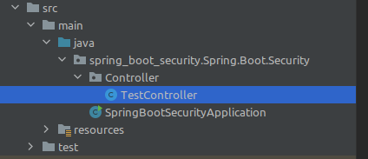

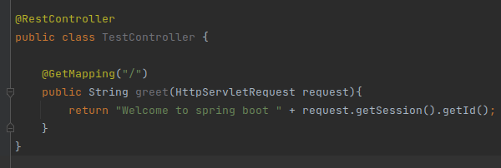

1. By default, it will show a login UI provided by Spring Boot

But if you comment out the Spring Boot security dependency, it will show the default page, which means our controller is not being guarded.

1. **Password** will appear on console, **username** = user.
2. Now run the project and test it

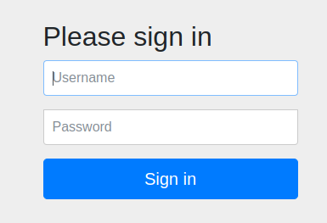

Note: we will not see this page if we disable security dependency on **pom.xml**

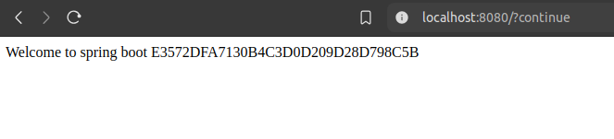

## **How are we seeing the login page when we request for the default page ?**

**Request Processing Flow:**

* When you access a controller in a web application, your request typically goes through:
  + **Filter Chain:** Filters intercept the request before it reaches the controller. These filters can perform tasks like authentication, logging, or request modification.
  + **Front Controller:** In frameworks like Spring MVC, the **Front Controller** is typically a DispatcherServlet. It serves as the central entry point for all incoming requests, delegating them to the appropriate controller.
* After the request is processed by the controller, the response follows the reverse path:
  + The response is processed by any filters (in reverse order) before being sent back to the client.

**Authentication and Validation:**

* If authentication or validation (e.g., checking the email and password) fails, the application (or filter) sends an appropriate response, such as an error message or a redirection to a login page. This can happen:
  + **In Filters:** If the filters are responsible for authentication, they might stop the request before it even reaches the controller.
  + **In the Controller:** If authentication or validation is done at the controller level, the controller will send the appropriate error message.

**Servlet and Tomcat:**

* These processes (filters, front controllers, and controllers) run within the **Servlet Container**, which is part of the **Tomcat Server**.
* Tomcat provides the runtime environment for Servlets and JSPs, handling tasks like managing threads, handling HTTP requests, and sending responses.

## **Change username and password & get CSRF token**

1. Go to src>main>java>resources>application.properties

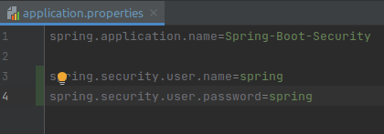

1. To get CSRF token

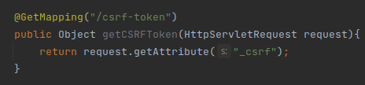

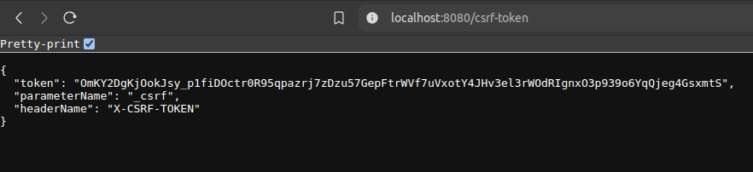

## **How do we change the way security filter chain works**

1. By default spring security provide us a lot of chain
2. But how to configure in our own way
   * We can do that creating **config class**
   * Create config class

src > main > java >package > new package (name it as config)

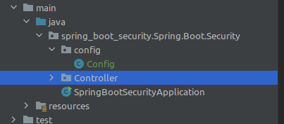

1. Code

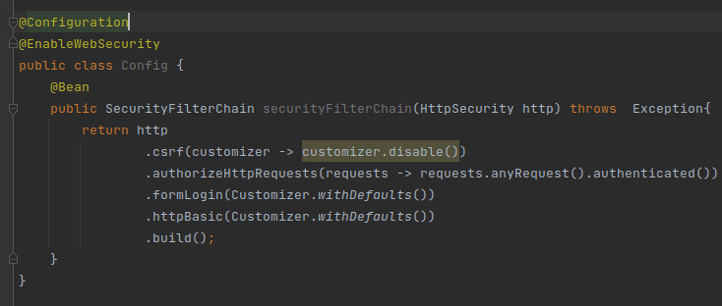

**Who is working behind the scene for validation username and password (Not used in codebase, but provided here for demonstration purpose only)**

* + **UsernamePasswordAuthenticationFilter** 
    1. Takes the credentials and starts the authentication process
  + **UserDetailsService**
    1. Helper to load user details for example fetching from database
  + In config file
    1. Use Bean, because it will be in the spring container, and your spring security will pick it from there.
    2. Create bean of **UserDetailService**

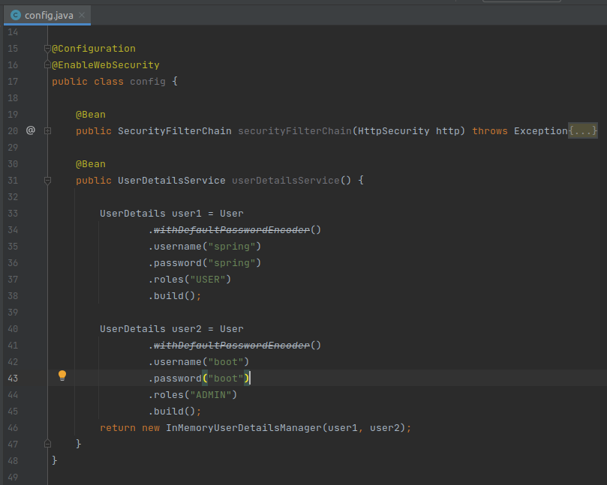

For demo we have create two user detail (but in real we get usually don't do that)

* + Now we can test it from POSTMAN

## **Connect with database**

1. When we pass a credential object (**Authentication Object,** still not authenticated) to the **Authentication Provider** (who will provide the service of checking it and validating it), it will provide an **Authentication Objec**t (Authenticated object).
2. First create database in PostgreSQL

Then create table

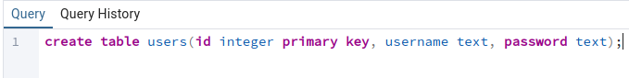

1. Connect with database

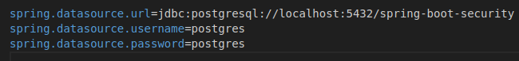

1. Folder structure

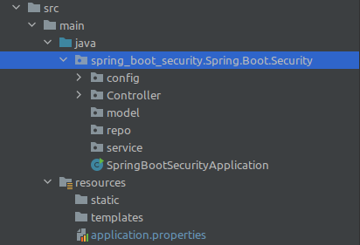

**NOTE :-** Controllers use services to handle business logic. Services interact with repositories to fetch or manipulate data, and repositories communicate with the database to perform these operations.

1. Create User class in model and create entity

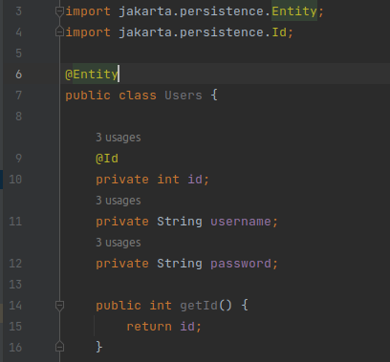

1. Create “useRepo” file (interface) inside the repo package
   * Extends JpaRepository with type of **Users** and **Integer**

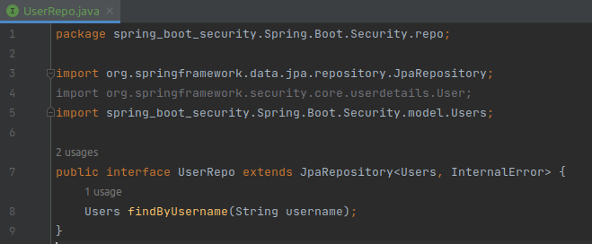

1. Inside the service package
   * Create MyUserDetailsService

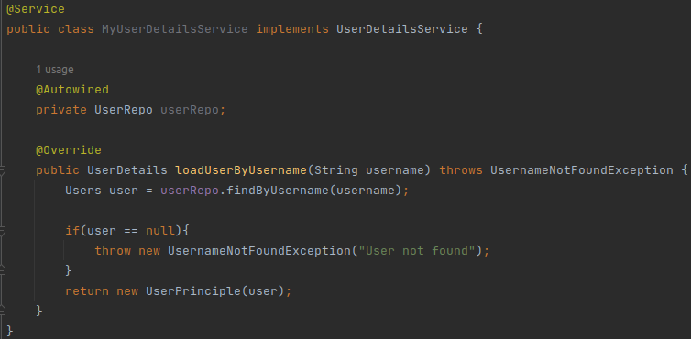

To return user object create UserPrinciple class inside the model package

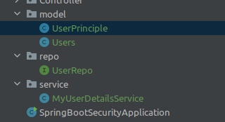

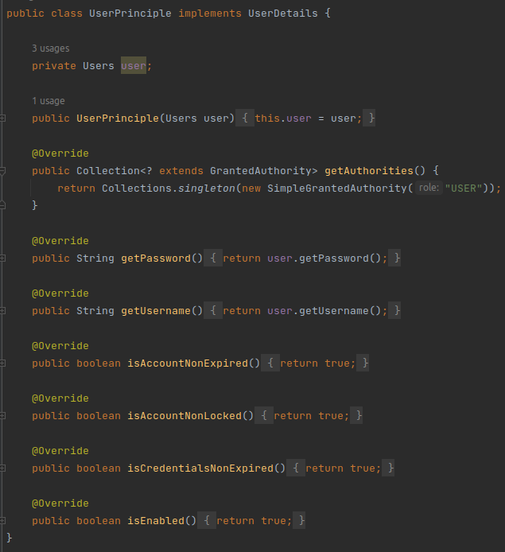

1. Now go to config file then add authentication provider

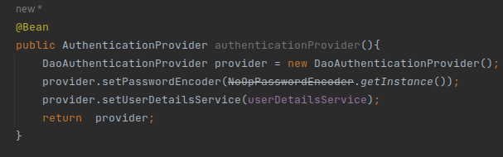

## 

1. Add a record to the users table, then try to log in

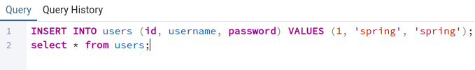

## **Connect with database**

1. When we pass a credential object (**Authentication Object,** still not authenticated) to the